Srinivasa Ramanujan Institute of Technology AnantHapurAMU

**(Affiliated to JNTUA, Approved by AICTE, New Delhi)(Approved by NAAC with ‘A’ Grade)**

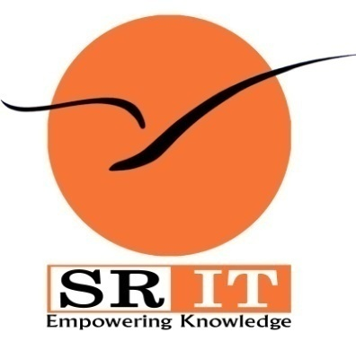

**Certificate**

This is to certify that the project report entitled A Smart Assessment System For Outcome Based Education is the bonafide work carried out by **M. Rajavardhana Reddy** bearing Roll Number 154G1A0568**, H. Sai Sree** bearing Roll Number 154G1A0577, **S. Sai Tejaswini** bearing Roll Number 154G1A0578and **R. Reddappa** bearing Roll Number 144G1A0529 in partial fulfilment of the requirements for the award of the degree of **Bachelor of Technology** in **Computer Science & Engineering** during the academic year 2018-2019.

**Guide Head of the Department**

M. Narasumhulu, M.Tech., Dr. B Lakshmi Narayana Reddy, PhD,

Assistant Professor Professor & HOD

Date:  **EXTERNAL EXAMINER**

Place: Ananthapuramu